The Four Minute Fitting Guide
Your objective: Snug, Level, Stable
You want the helmet to be comfortably touching the head all the way around, level and stable enough to resist even violent shakes or hard blows and stay in place. It should be as low on the head as possible to maximize side coverage, and held level on the head with the strap comfortably snug.
Be Prepared for the Worst
Heads come in many sizes and shapes. You should be prepared for the possibility that the helmet you are trying to fit may not work on this particular head. And unfortunately, you can expect to spend ten to fifteen minutes to get a helmet fitted right.
First, Use the Fit Pads or Ring
Many helmets use a fitting ring. With these “one size fits all” models you begin by adjusting the size of the ring. Some of them may require the ring so tight for real stability on your head that they feel binding, but if loosening the ring produces a sloppy fit, that helmet is not for you.

Helmets that fit with pads come with at least one set of foam fitting pads, and if you get a second set of thicker pads they can be used to customize the shape. You can often remove the top pad entirely or use the thinnest ones. This lowers the helmet on the head, bringing its protection down further on the sides. It may reduce the flow of cooling air slightly, but probably not enough to notice.
Adjust the fit pads by using thicker pads on the side if your head is narrow, or thinner pads in the back for longer heads. The pads should touch your head evenly all the way around, without being too tight. The helmet should sit level on the head, with the front edge one finger width above the eyebrows, or just above the frame of your glasses. If you walk into a wall, the helmet should hit before your nose does!
Then, Adjust the Straps
Now put the helmet on and fasten the buckle. Be sure the front is in front! Adjust it to the “Eye-Ear-Mouth” test. When you look upward the front rim should be barely visible to your eye, the Y of the side straps should meet just below your ear, and the chin strap should be snug against the jaw so that when you open your mouth very wide you should feel the helmet pull down a little bit. If the junction is sewn with no adjustment, skip the next two paragraphs.
With the helmet level on your head, adjust the rear straps, then the front straps, to get the Y where the straps meet just under your ear. You may have to slide the straps across the top of the helmet to get them even on both sides. Adjust the chin strap so it is comfortably snug. Now adjust the rear stabilizer if the helmet has one. It makes the helmet feel more stable, but only a well-adjusted strap keeps it on in a crash.
When you think the straps are right, shake your head around. Then put your palm under the front edge and push up and back. Can you move the helmet more than an inch from level, exposing your forehead? If so, shorten the strap in front of your ear. Now pull up on the back edge. Can you move the helmet more than an inch? If so, tighten the rear strap. On a True Fit helmet you can only tighten the neck strap.
When you are done, your helmet should be level, feel solid on your head and be comfortable. It should not bump on your glasses (if it does, tighten the rear strap). You should forget you are wearing it most of the time, like a seat belt. If it still does not fit that way, keep working with the straps and pads, or try another helmet. If your helmet is a Bell True Fit, there are no adjustments and you have to try another helmet.
Strap Creep
Now lock in the fit you have achieved to prevent “strap creep” over time. Lock the side buckles carefully if you can. Or wrap rubber bands around the strap and snug them up under the side buckles so they won’t slip. You can even sew the straps with a needle and thread.

You’re Done!

Quick Summary

- Helmets are not just hats! They must be level on your head and strapped on securely to be protective in a crash.
- You want the helmet to be level on the head, not tilted back or sideways.
- You want the fitting pads inside to be touching all the way around.
- You want the strap to be comfortably snug.
- With the strap fastened you should not be able to get the helmet off with any combination of twisting and tugging
- The helmet should not bump on glasses or sunglasses in the front.
- The helmet should be comfortable enough to forget that it is on your head after only a few minutes.
- It will take you more fiddling time than you expect to get it this way!

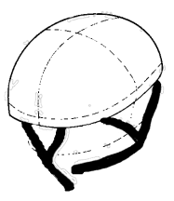
If you have 4 more minutes, read on!

When to Replace a Helmet?
Replace any helmet if you crash. Impact crushes some of the foam, although the damage may not be visible. Helmets work so well that you need to examine them for marks, dents or foam crush to know if you hit. Most manufacturers recommend replacement after five years. We think that depends on usage, and studies have shown that most helmets given reasonable care are good for longer than that. We are not aware of any crash yet where helmet age was a factor. But if your helmet dates back before 1990, it's time to replace it for today’s improved impact performance. If it’s newer, you may get more added protection from fitting your current helmet carefully than from buying a new one. Some newer models have new technology to reduce rotational force in a crash that may help in some situations. Replace the buckle if it cracks or any piece breaks off.

Bicycle Helmet Safety Institute
4611 Seventh Street South
Arlington, VA 22204-1419 USA
(703) 486-0100 info@helmets.org
helmets.org
We are all volunteers, funded by consumers like you.
©BHSI, 2024 Permission granted to reproduce on paper for non-profit use.
Warning: Children must always remove helmets before climbing on playground equipment or trees, where a helmet can snag and choke them.

How to Fit
A
Bicycle Helmet

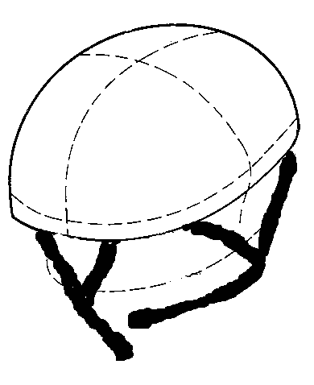

Bicycle Helmet Safety Institute

Consumer funded
helmets.org

