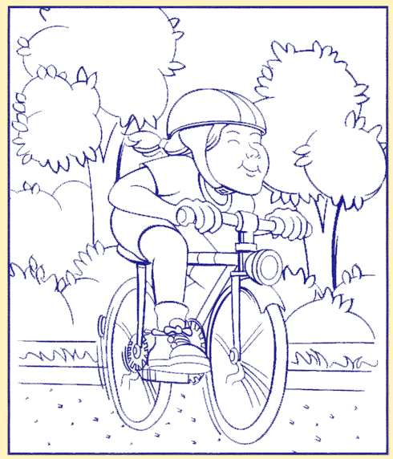

Ride Safely and Wear Your Helmet!

